**Effects of Gummy Bear Color on the Rate Water Absorption**

Tanay Deshmukh

Ms. Root

AP Environmental Science AB

August 14, 2020

# Introduction

* In this lab, I will be determining whether the color of a gummy bear influences the rate at which it absorbes water. My hypothesis is that, if I leave the three different colors of gummy bears in their own cups of water, then there will be no difference in how much water the bears absorb. We will be measuring the amount of water in the cups before and after the gummy bears have soaked in them for an hour to determine how much the mass of the water has changed.

# Materials

* The gummy bears are made of glucose syrup, sugar, water, gelatin, less than 2% blend of coconut and palm oil, citrc acid, malic acid, natural flacors, pectin, and colors made of: annatto extract, blueberry and carrot concentrates, and purple carrot juice concentrate (Gummy Vites™ Daily Multivitamin*).*
* Water from either a tap or filter. Make sure the source of the water is consistent.
* Three cups (one for each color of gummy bear).
* A kitchen scale to measure the mass of the water.
* Some sort of timer.

# Procedures

* Aquire three gummy bears with different colors.
* Fill the three cups up with water and record their weights.
* Place the gummy bears in the cups so that there is only one bear in each cup. Every cup should have a different color bear.
* Set an hour long timer. Make sure the cups are left in the same environment (preferably indoors and air conditioned).
* Once the timer goes off, take the gummy bears out of the cups. Make sure you mark which color gummy bear was in which cup.
* Weigh the cups filled with water after the hour of gummy bear soaking and record their wieghts accordingly. Make sure you keep your data organized by which color bear was in which cup.

# Data Collection

|  |  |  |  |
| --- | --- | --- | --- |
| Gummy Bear Color | Water Filled Cup Weight Before (kg) | Water Filled Cup Weight After  (kg) | Weight of Water Lost  (kg) |
| Yellow | 0.402 | 0.401 | 0.01 |
| Orange | 0.400 | 0.399 | 0.01 |
| Red | 0.402 | 0.401 | 0.01 |

* Weight of each gummy bear both before and after soak: 0.02 kg
* Image of lab:

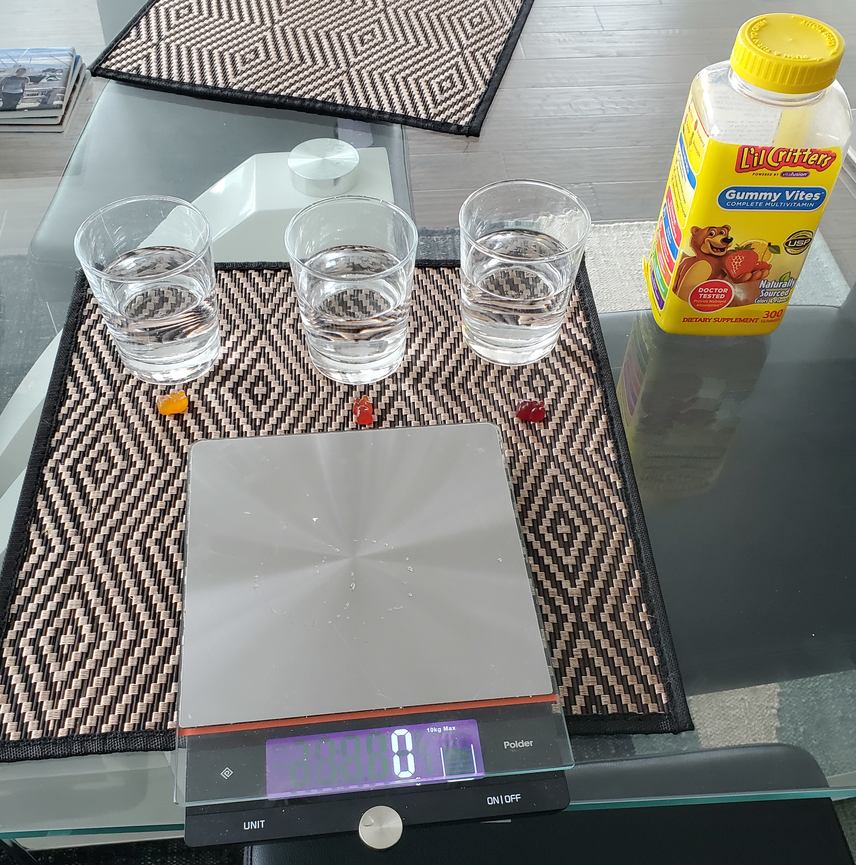

* Note: Bears swelled up slightly after an hour of soaking but remained 2 grams.

# Analysis and Discussion

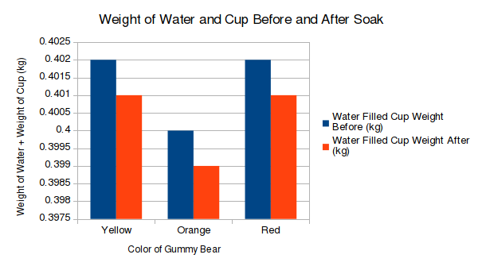

* Weight of water lost = (weight of water and cup before) – (weight of water and cup after)
* As can be seen in the chart above, all of the cups of water lost 0.02 kg of weight as a result of the gummy bear soaking up the water.
* One confusing thing is that the mass of the gummy bears did not change at all. Theoretically, their masses should have increased by two grams. They did at least, seem swelled up visually.
* Questions:
  1. How much did your gummmy bears change in mass by?
     1. The gummy bears did not change in mass.
  2. Was there a difference in how much your water changed mass based on color?
     1. There was no difference between the mass of water lost between the cups of water with bears of different colors.
  3. Why might your gummy bears have or not have changed in mass?
     1. They might not have changed in mass significantly because the water was lost to evaporations.
  4. Did this experiment prove or disprove your hypthesis?
     1. Since there was no difference in the amount of water lost, I conclude that the colors of the bear did not play a significant part on the water absorption speed of the bears.
  5. Would the result have changed if the water was a different temperature?
     1. I predict that the amount of water lost would have changed with a change in termperature, but the conclusion that the colors of the bears don’t differentiate the loss of water would remain true.

# Conclusion

* My hypothesis was that, if I leave the three different colors of gummy bears in their own cups of water, then there will be no difference in how much water the bears absorb. After an hour of soaking the bears in the water, there was no difference between how much water the cups lost and between the masses of the bears after the soak. This leads me to believe that color did not play a significant role in the rate at which the bears absorbed water over an hour. One issue that I found was the the bears did not gain any mass during the experiment. Although they seemed bloated, their masses stayed two grams. I assume that this may be because the mass they gained was too small for my scale to measure. It is also possible that the two grams of water lost may have just evaporated. Either way, my conclusion that the colors did not affect the out come remains.

# References

*Gummy Vites™ Daily Multivitamin*. www.gummyvites.com/en/lil-critters/products/lil-critters-gummy-vites/supplement-facts.